Process & Decision Documentation
This document is used to make your design and development process visible. At this stage of your academic career, you are expected not only to produce finished work, but to articulate how decisions were made, how ideas changed, and how collaboration (for the assignments that include group work) unfolds
In professional and co-op contexts, employers do not only evaluate your final projects in your portfolio. They often ask candidates to explain their process, justify trade-offs, reflect on iteration, and describe their roles within a team.
You will need to submit a modification of this document for every group assignment (A1 – A3) and a shorter version for your individual assignments (Side Quests and A4).
For A1 – A3, this is a group document submitted once per group. Each group member must clearly document their own role and responsibilities. Different roles will naturally produce different design processes.

Project/Assignment Decisions
Use this section to document key decisions that shape the direction, scope, or outcome of the assignment. The purpose is to make your judgement and reasoning visible, not to record every action taken.
What you include here should reflect decisions that mattered: moments where you chose one path over another, changed direction, or adapted to constraints.
The expected length and detail depend on the assignment.

Side Quests and A4 (Individual Work)
Keep this section brief, typically 2 to 4 sentences.
- Asked prof for help when troubleshooting trying to download the software

Role-Based Process Evidence
This section documents how your work developed over time and provides concrete evidence of your process. It is used to make your thinking, iteration, and decision-making visible, whether or not GenAI was used. You may reuse relevant process evidence across documents where appropriate, as long as it accurately reflects the work for that assignment.
For group assignments (A1 – A3), this section is completed collectively, with clearly attributed role-based entries. For the group, your entries should correspond to elements shown in your process overview visualization such as stages, iterations, or decision points.
For individual assignments (Side Quests and A4), this section is completed individually, using a simplified version of the same structure. For Side Quests, you may omit sections below where no meaningful decision-making occurred. For example, for the first side quest which you need to just upload a blank p5.js to GitHub, you must have to remove a significant amount of the process based evidence as not a lot of design decisions were made.
Examples of acceptable process evidence include (but are not limited to):
- Screenshots of video editing timelines
- Drafts of scripts or research notes
- Annotated sources
- Sketches or diagrams
- Early document outlines
- Prototype screenshots
- Code snippets or commits
- Before-and-after revisions
Project management artifacts (e.g., task boards, timelines, coordination) may be included here when they are relevant to understand how assignment-level decisions were made.
If GenAI was used to support planning, coordination, or role management, this should be noted briefly here as part of the process evidence. Deeper reflection on how GenAI affected teamwork, fairness, and coordination over time belongs in the GenAI Reflections (A4).

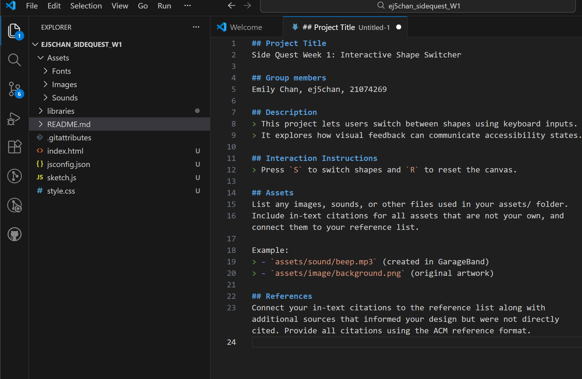

Entry Header
Name: Emily Chan
Role(s):
Primary responsibility for this work:

Goal of Work Session
Briefly describe what you were trying to accomplish during this phase of the assignment.
- download software
- create folders
- connect repos
Tools, Resources, or Inputs Used
- Lecture Notes

GenAI Documentation
No GenAI used for this task

